- Though UK inflation surprised on the downside in December, this was largely due to temporary factors. Indeed, the rise in wholesale gas prices over the past few weeks means that we've revised up our forecast for CPI inflation in 2025 to 3% from 2.8% last month.
- December's drags from the volatile air fares and accommodation categories are likely to unwind in next month's release. We expect inflation will spend most of 2025 around the 3% mark, with rising wholesale energy prices, a weak pound, and fiscal policy changes more than offsetting the drag from a gradual cooling in wage growth.
CPI inflation surprised on the downside in December, edging down to 2.5% from 2.6% in November. Lower-than-expected services inflation was the reason for December's softer outturn, with the volatile air fares and accommodation categories accounting for the bulk of the undershoot. The Office for National Statistics suggested the choice of dates used was a key factor in the lower outturns. The softer services reading more than offset the impact of base effects in the core goods and fuel categories, with the latter impact having been compounded by pump prices rising m/m between November and December. RPI and RPIX inflation also fell by 0.1ppts to sit at 3.5% and 2.9% in December.
The downward pressures from air fares and accommodation should unwind in next month's data, and we expect this to mark the start of an upward trajectory for inflation that will last until early autumn. Indeed, the outlook has deteriorated since last month because of the recent surge in wholesale gas prices. This is likely to mean that the energy price cap rises further in April, after an increase of just over 1% at the start of this month. As a result, we've nudged up our forecast for CPI inflation in 2025 to 3%, from 2.8% last month.
Alongside the impact of higher energy prices, the weakening in sterling will push up the prices of imported goods. Fiscal policy changes will also create upward pressure on inflation via firms passing on some of the cost of higher national insurance contributions and the introduction of VAT on private school fees. But these effects should prove temporary, and with easing wage growth set to cool services inflation, we expect CPI inflation to cool as we move through 2026.
Chart 1: We've revised up our 2025 forecast for CPI inflation to 3% due to higher gas prices
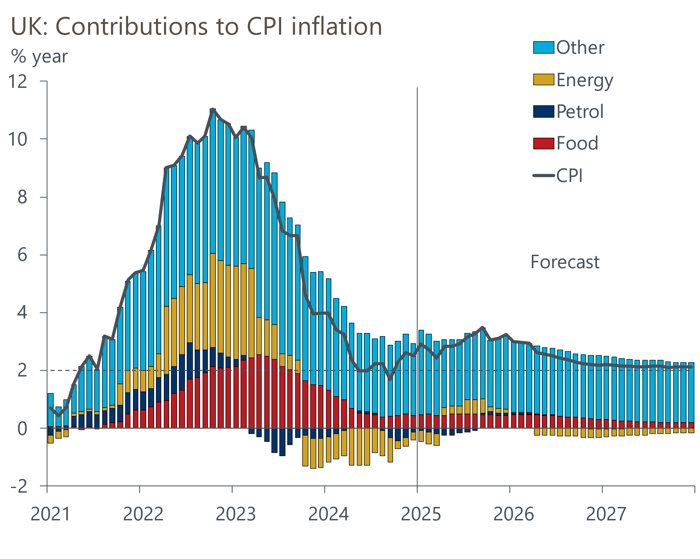
Source: Oxford Economics, Haver Analytics

